**Database Lab project proposal**

**Net – Coffee (or CafeGamingNet) database**

**GROUP NUMBER 3**

**Team Members:**

**Tống Thành Vinh – 20194884**

**Phạm Vũ Huy – 20194779**

**Phùng Hải Nguyên – 20194812**

1. **Definition of <<CafeGamingNet>>:**

* An **Internet cafe** (also known as a **cybercafe**) is a [café](https://en.wikipedia.org/wiki/Coffeehouse) (or a [convenience store](https://en.wikipedia.org/wiki/Convenience_store) or a fully dedicated internet-access business) that provides [Internet](https://en.wikipedia.org/wiki/Internet) access to the public. The fee for using a computer is generally charged as a time-based rate.
* The café supplies food and drinks especially coffee for the customer to enjoy and surf the Internet.

1. **Who can use this database?**

* The administrator will be the one who mainly use this database, not only to manage the whole store, but to also help the customers when they are in need. For instance, when the customer wants to know where the absent computer spot is, admin can help them. 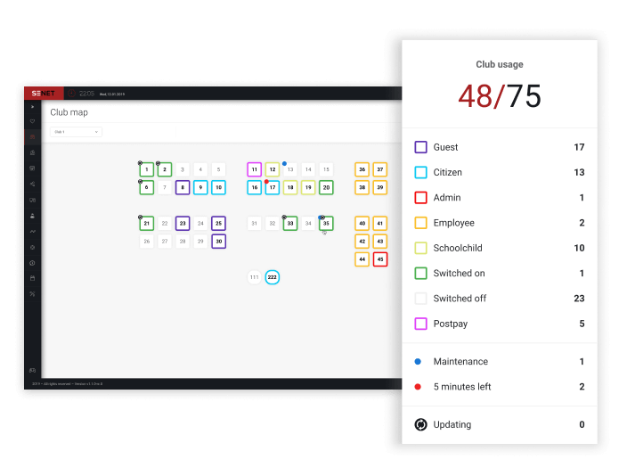
* The user or customer can also use but at a limit. For example, they can retrieve the food and drinks database (but not be able to edit it) to make order. Not only that, this database will help the user to see their own data such as the remaining money. E.g: 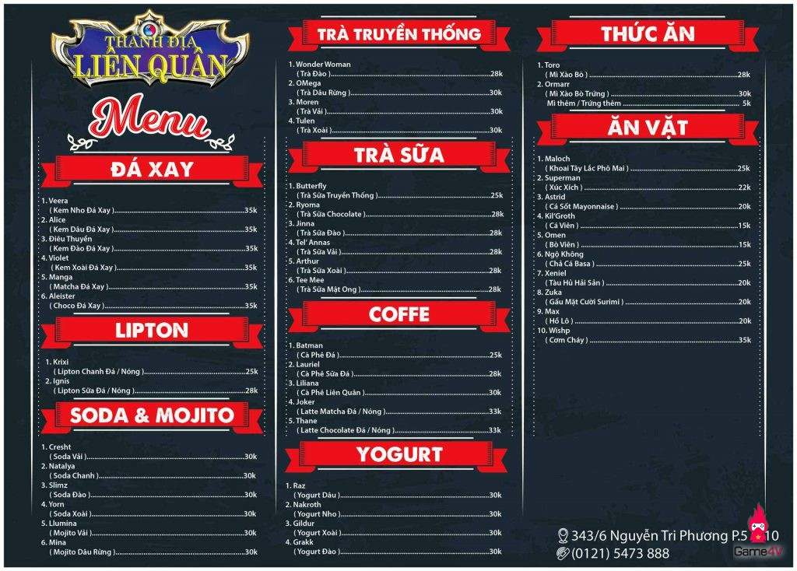

1. **Why do we need this database?**

* To manage a lot of informations while running this business (in reality, a netcafe cyber can serve up to hundreds of users per day – means up to thousands of information.
* To optimize the system to earn more profits (main purpose).

1. **General description of <<CafeGamingNet>>:**

* **Ordering computer:**
* The customer will order a computer with the admin, then go to the ordered computer’s spot to start using the store’s services.
* If all computers are occupied, the customer can either wait or leave. No reservation before coming.
* If successfully placing order, the user will be charged after finished using computer, depends on the type of computer.
* **Using the computer process:**
* When using the computer, if the customer wants to, they can order food or drink.
* Ordered food and drinks will be charged directly from user account, this can only happen if the customer has enough money in the account. If is not then the user is asked if they want to add money or cancel the order.
* If the user run out of money while using the computer, they will be asked if they want to add money or they will have to leave.
* **If users forget their password then the admin can help restoring them if they tell the admin exactly their identity card’s serial.**
* **User_account contains the user’s information and their money which is injected to their account to be used.**